# 

# **THE UNIFORM STORE**

# **“PROJECT”**

**Document Type :** User Guide Documentation

**Group Members**

* Arisha Shahid
* Eman Kanwal
* Uneeza Fareed
* Quratulain Aslam

**Institute:** Aptech Learning

PROJECT INSTRUCTOR:

SIR ZAFEER

# **📘 2. HOME PAGE GUIDE**

## **🔹** Navigation Bar

• 🏠 Home – return to main page.

• ℹ️ About – details about the brand.

• 👕 Products – explore all uniforms.

• 🛠 Services – see available facilities.

• 📞 Contact – reach us easily.

**

## **🔹** Hero Banner

• Displays featured uniforms and highlights.

• CTA button helps users quickly navigate.

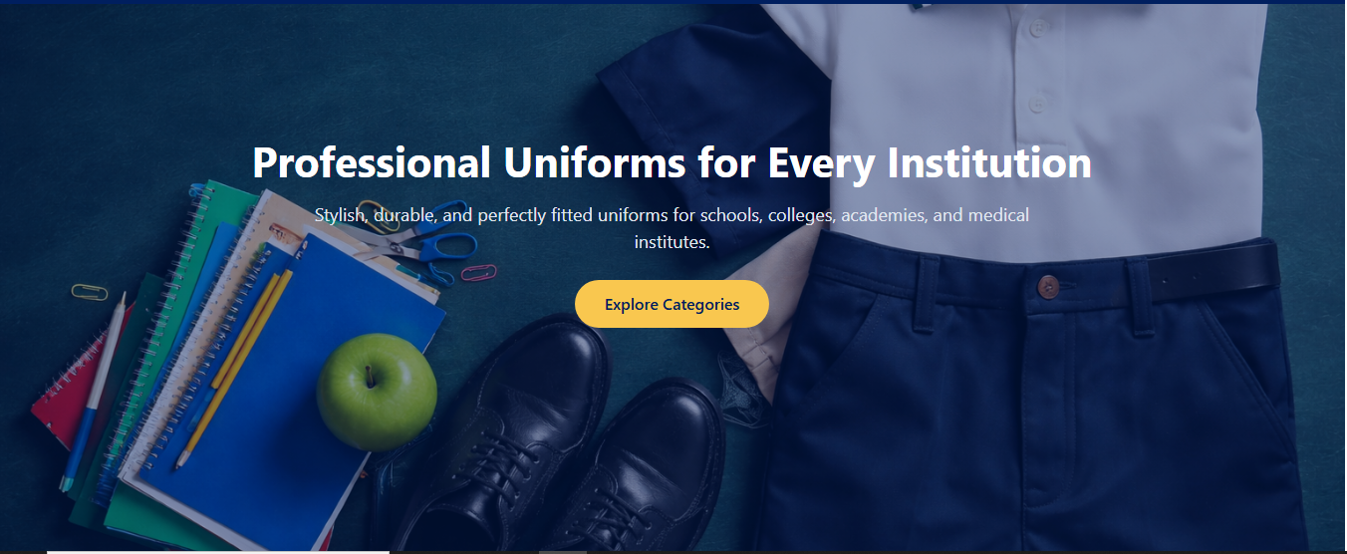

## **🔹** About Highlight

• Provides short introduction to the store.

• Button leads to full About page.

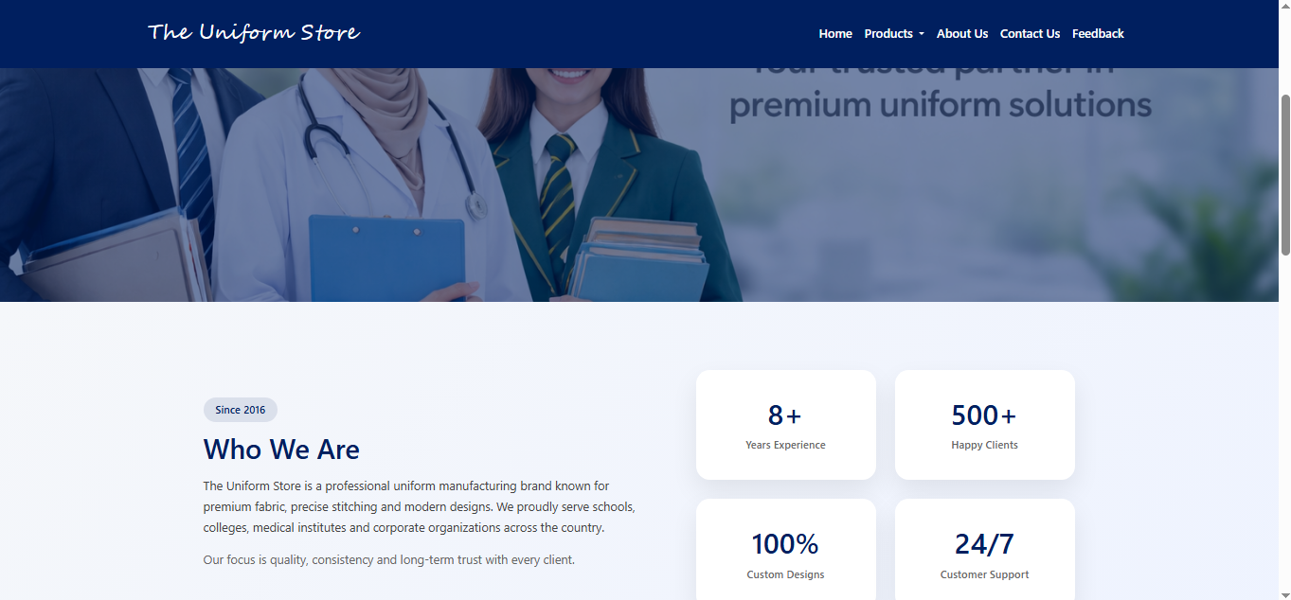

# **📘 3. PRODUCTS PAGE GUIDE**

## **🔹** BrowsingProducts

• Scroll through multiple categories.

• Each product card shows image + price + size.

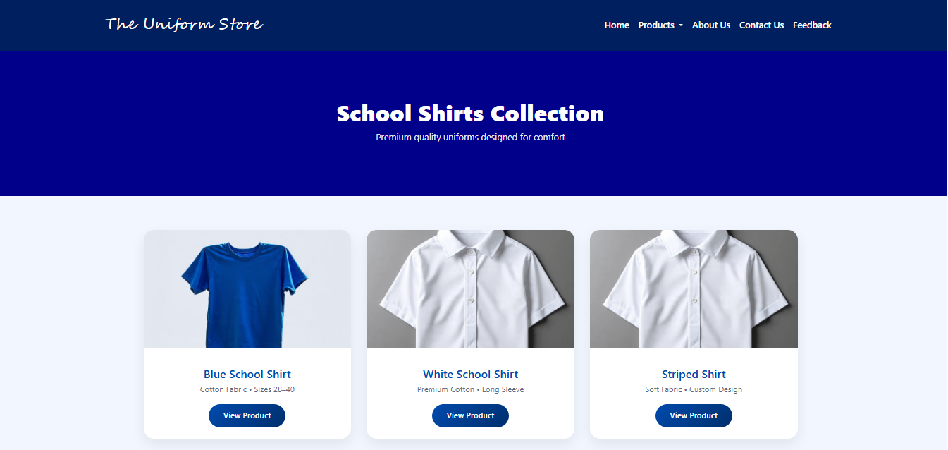

## **🔹** Filters

• Category filter for easy navigation.

• Price filter to fit your budget.

• Size filter for perfect selection.

# **📘 4. SERVICES PAGE GUIDE**

• ✂ Custom Stitching options for perfect fitting.

• 🧵 Embroidery service for logos and names.

• 📦 Bulk orders for institutions and companies.

• 🚚 Fast and reliable delivery service.

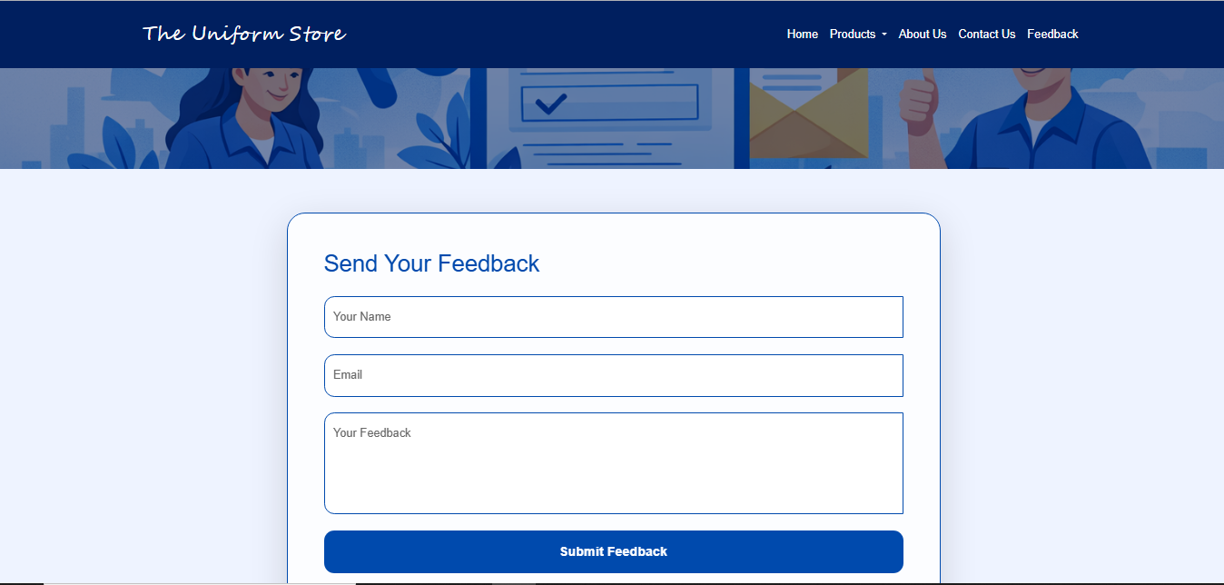

# **📘 5. UNIFORM CATEGORIES**

• School Uniforms – durable and comfortable.

• Corporate Uniforms – neat professional look.

• Sports Uniforms – breathable performance wear.

• Medical & Industrial Uniforms – strong and reliable.

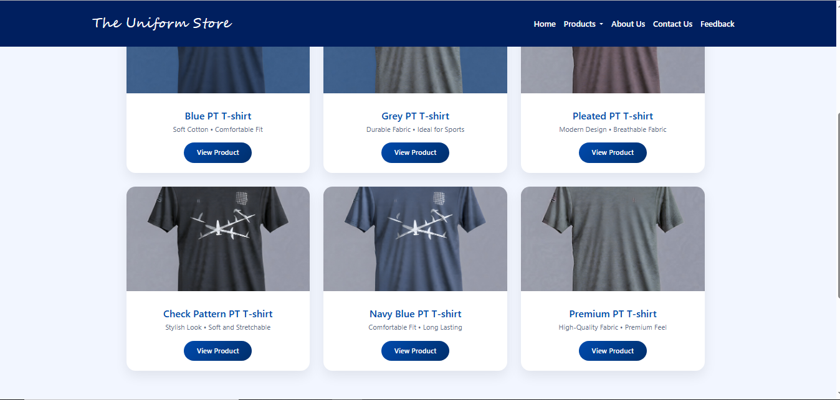

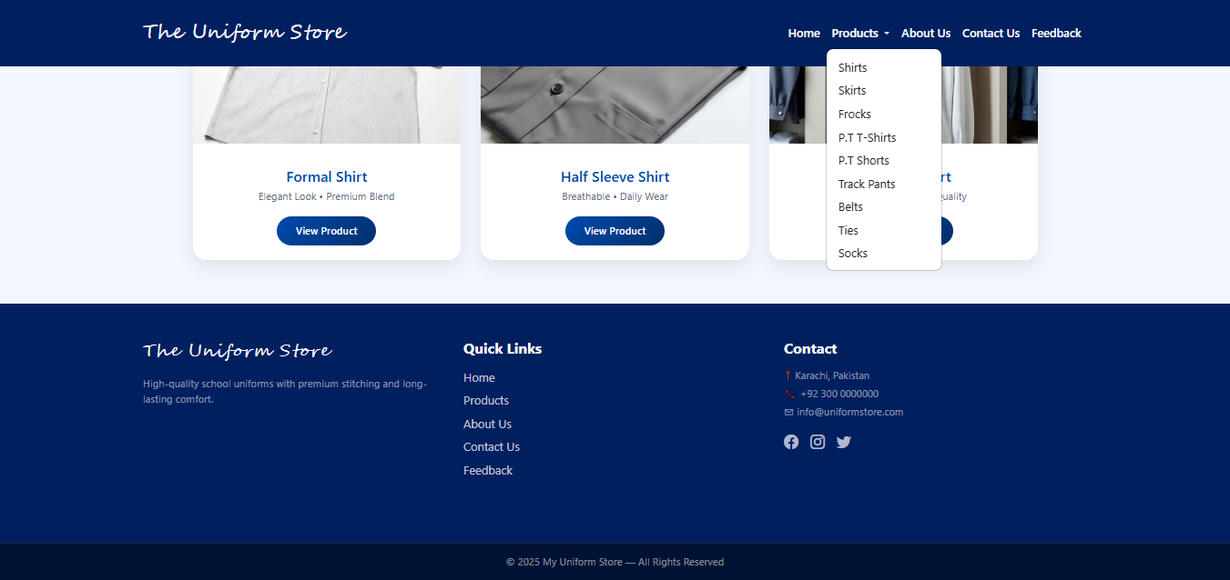

# **📘 6. QUALITY STANDARDS**

• Tested fabric strength for long life.

• Advanced stitching for premium quality.

• Designed to stay fresh after multiple washes.

• Quality control checks ensure perfection.

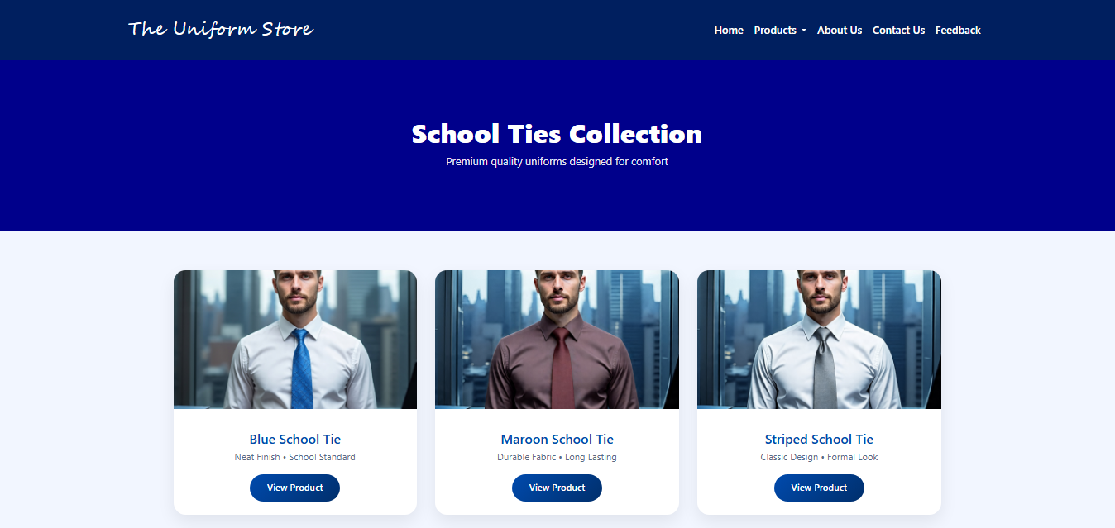

# **📘 7. CONTACT PAGE GUIDE**

• 📧 Fill form for quick queries.

• 📞 Phone support available.

• 📍 Visit store physically.

• 🤝 Fast response team support.

